Pandora’s Box

CS4398 SM4

Taj Kirkpatrick

Dillon Kern

Ben Kownacki

David Kim

1. Description of execution of acceptance testcases illustrated with screenshots of all the windows and pop-up windows of the system along an acceptance testcase

**Help**: Shows all available commands. Executed by typing “!help”. Accepted if all commands are printed.

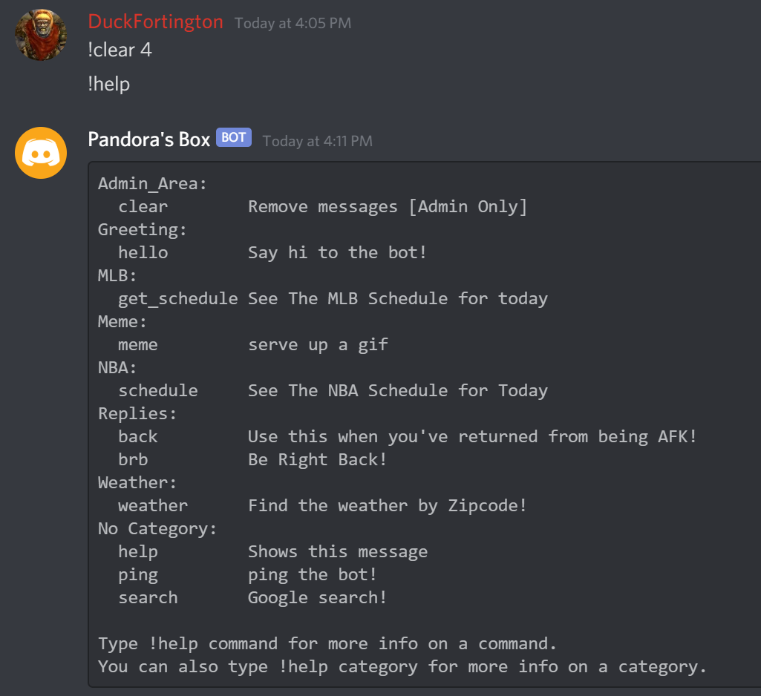

**Hello**: Has the bot say hi to the user. Executed by typing “!hello”. Accepted if the bot says “Hi There “ followed by an @ mention of the user who typed the command.

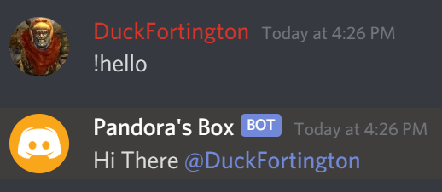

**MLB**: Bot states all events in MLB schedule for the current day. Executed by typing “!mlb”. Accepted if the bot states all MLB games for the current day.

.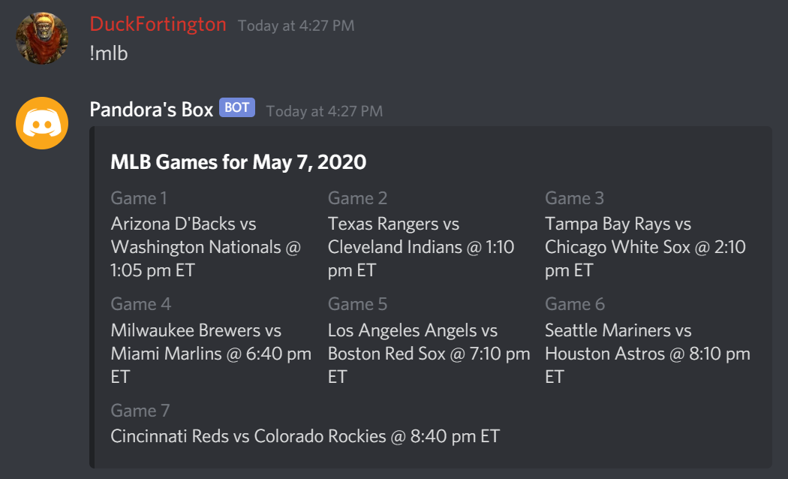

**BRB**: Lets users know that the invoking user is away from their keyboard if they try to mention that person between when they invoked the BRB command and the time they specified they would return. Executed by typing “!brb {time in minutes}”. Accepted if, when a user mentions the user who invoked the command, the bot replies to that user and says the invoking user will be back at the time they specified they would return.

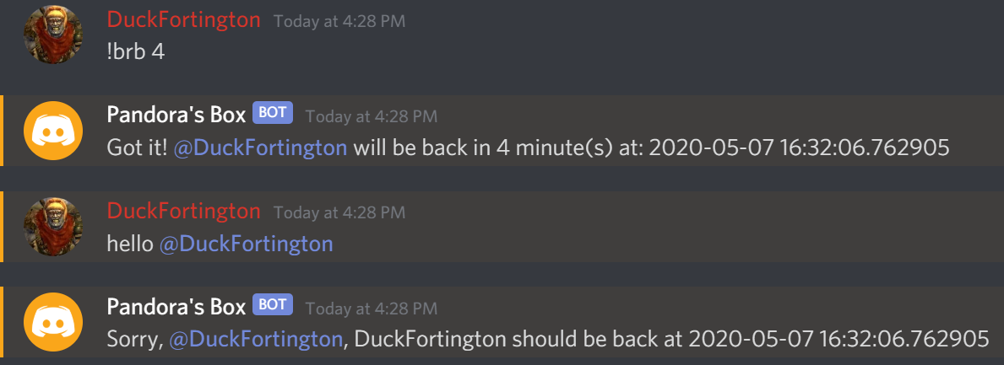

**Back**: Invoked after a user has used the BRB command, this command tells the bot that the user has returned so it does not tell other users that they are away if they mention the invoking user. Executed by typing “!back” between a BRB command and the end time specified. Accepted if the bot does not reply to a user that mentions an away user after the back command is executed.

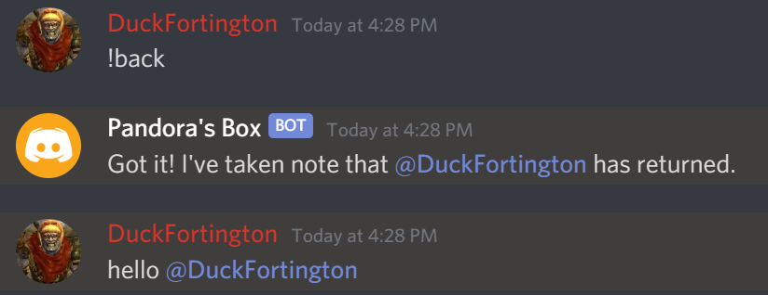

**Weather**: Tells users a weekly summary of the weather for a specified zip code. Executed by typing “!weather {zip code}”. Accepted if the bot states the weather for the correct zip code after user calls the command.

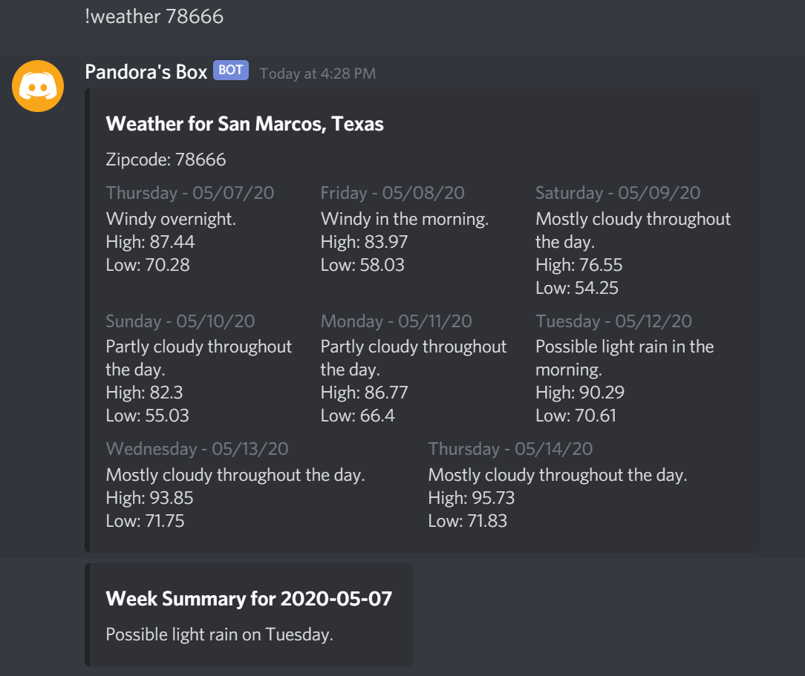.

**Ping**: Replies to a user to let them know the bot is active. Executed by typing “!ping”. Accepted if the bot replies “pong” after a user types “!ping”.

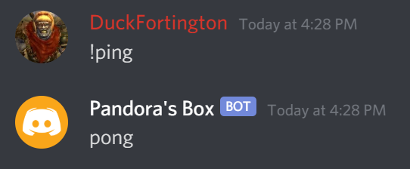

**Meme**: Allows users to get a gif from gfycat and insert it into the chat. With no parameters, it will reply a random gif, with parameters, it will reply with a random result from a set of random gifs fetched. Executed by typing “!meme” or “!meme {search term}”. Accepted if the bot sends a message with a random gif after the user has invoked the command with no parameters and replies with a related gif if the user invokes the command with parameters.

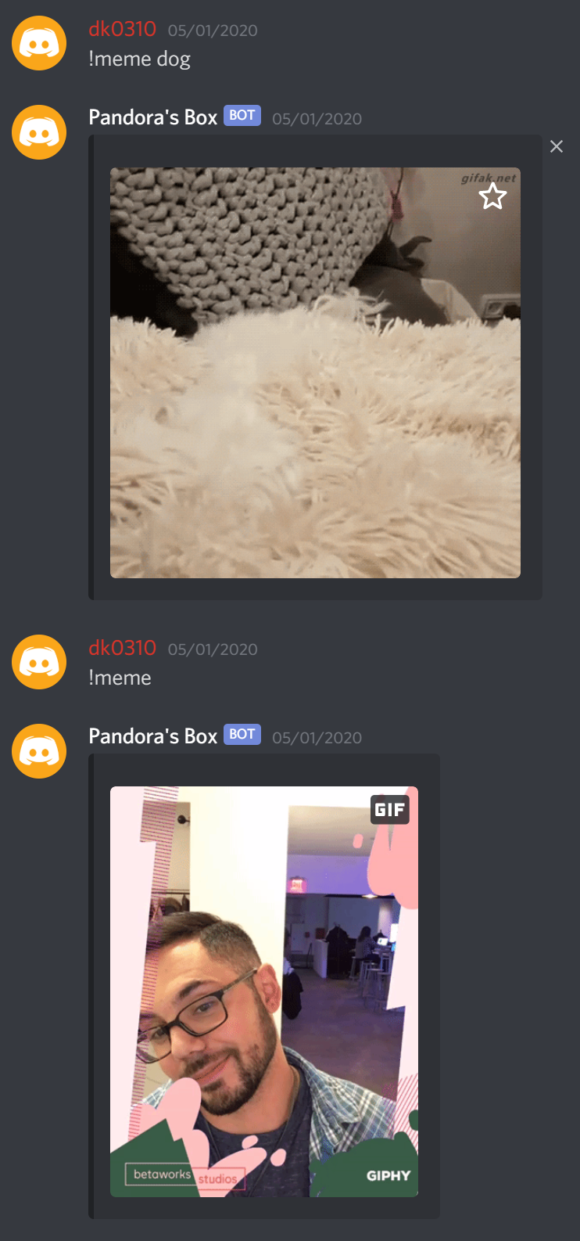

**Autorole**: Automatically assigns a user the role of Class Member upon joining. Executed when a new user joins the server. Accepted if a new user joins and is assigned the role of Class Member. **See the Greeting command description for a screenshot of this command.**

**Greeting**: Greets new users when they join the server. Executed when a new user joins the server. Accepted if the bot greets a new user on their first time entering the server.

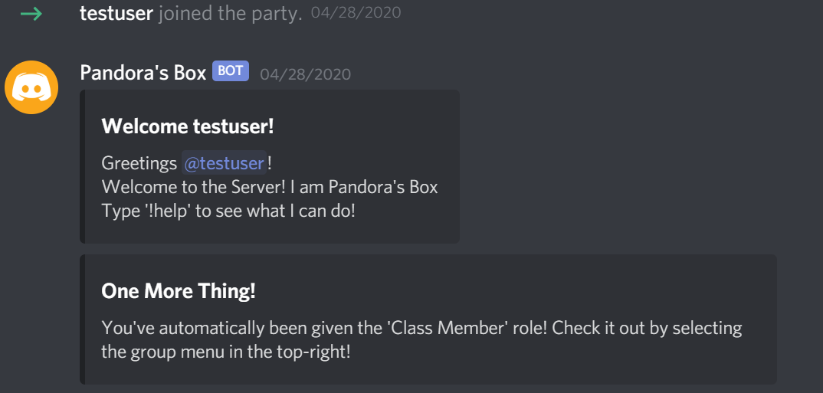

**Clear**: Clears a specified number of messages in chat. Executed by typing “clear {number of messages to clear+1}”. Accepted if the specified number of messages are deleted from the chat after the command is entered.

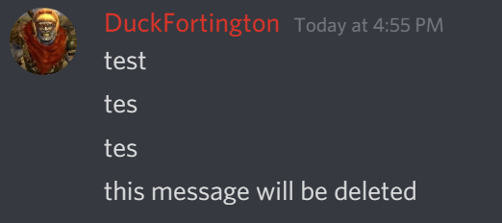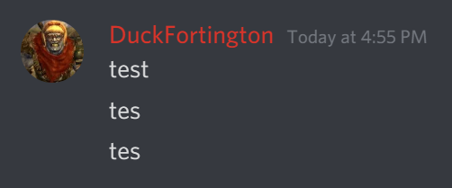

1. UML class diagram

We could not generate an overall class chart diagram because the user is the driver, but to demonstrate that we know how to get class diagrams automatically generated, the following are pictures of class diagrams automatically generated by PyCharm for all of our cog classes:

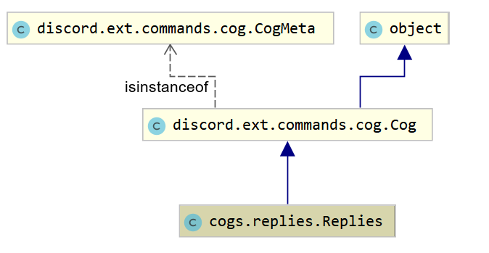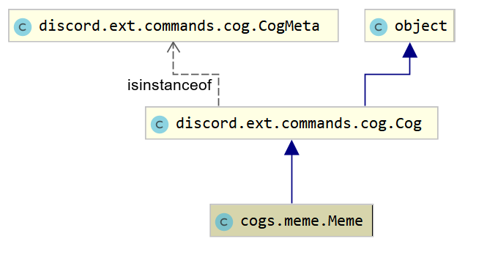

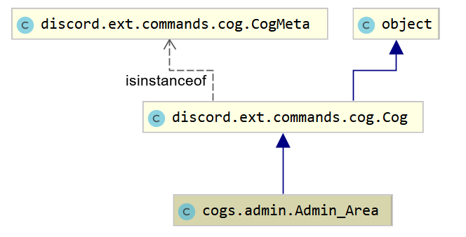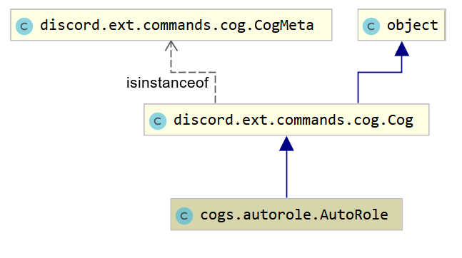

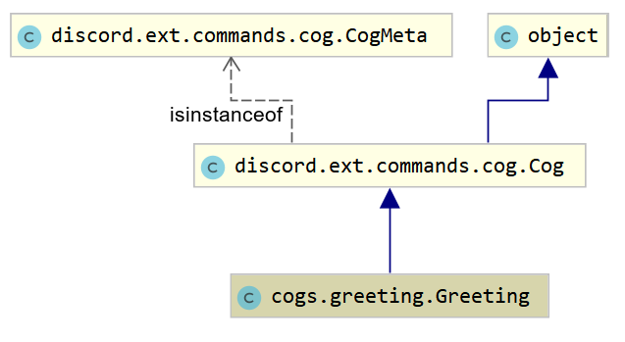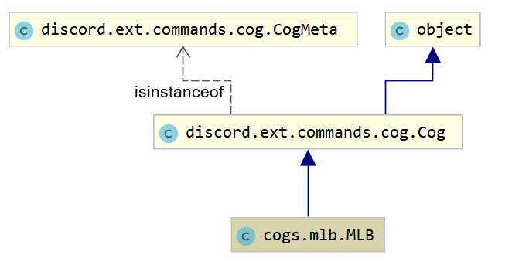

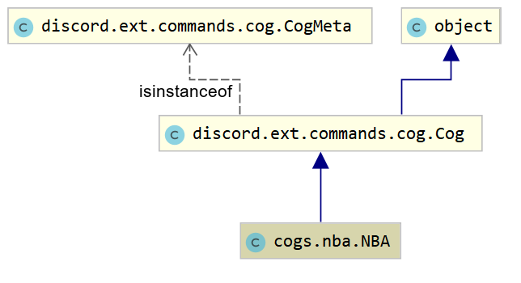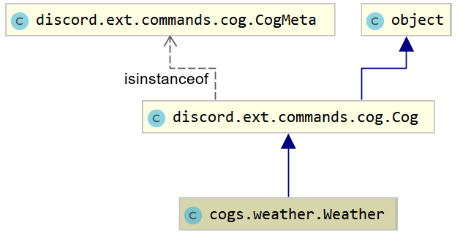

1. System statechart diagrams

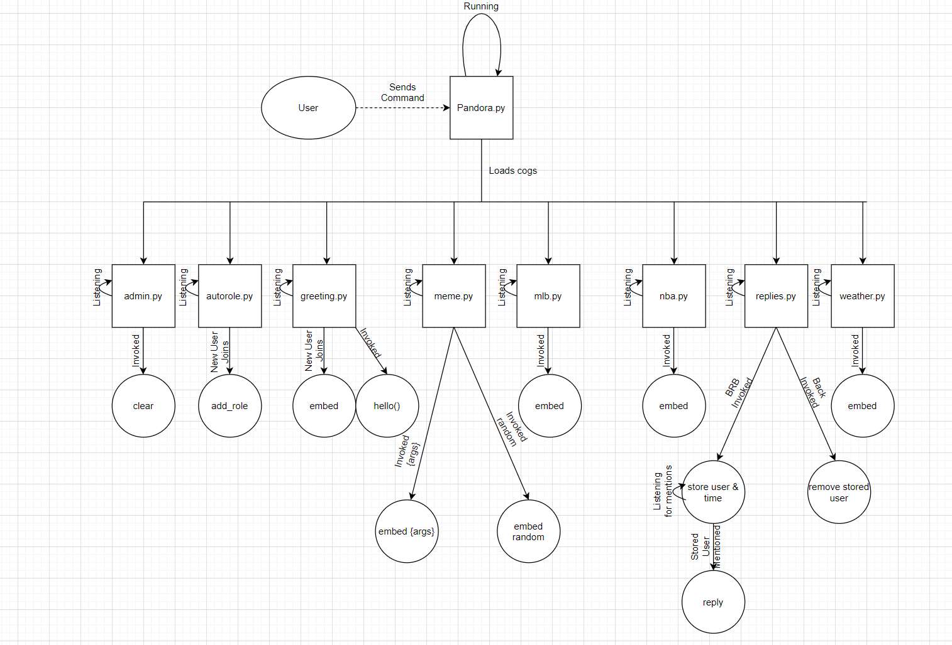

1. Textual description of the structure of your system and implemented algorithms critical for the system's behavior

The system (bot) is structured as a main pandora.py driver program which runs cogs that users can activate by typing commands in the Discord app or web app or typing certain other non-command messages in some cases. When run, pandora.py loads all the cogs available to it and keeps them listening to Discord for commands or events. Commands are run by any user typing a command preceded by an exclamation point. For example, to use the help command, a Discord user would type !help and the bot processes that command and performs an action based on the code in the relevant cog. The bot utilizes the Discord Python API to perform its functions. If the user tries to enter a command that does not exist or invalid arguments, the bot tells the user to check the format of their command and try again. It is critical that you join the server to test the bot, here is an invite link: <https://discord.gg/FtNtdCE>. Please also let us know when you are testing it so we make sure the bot is active for your tests.

1. Source code (archive of the project directory structure)

Available here: <https://github.com/CS4398-Group4/TermProject>

1. API docs produced by javadoc, if using Java

We are not using Java in our project.

1. Unit test cases in the code (for the Model and Controller classes and their methods or for most critical classes that contribute most to the behavior of your system), use JUnit if using Java.
   1. In all cogs we test for invalid input when calling the command. If an error is encountered when the command is invoked, a message is returned to the user.
   2. Cog: Autorole - Unit Test: if channel is None
      1. When a user initially joins the server, the channel they joined within is immediately recorded by the bot. Upon joining, if the logged channel is a NONE object, the program raises a value error and the user is not given an automatic role. This error is logged.
   3. Cog: Admin - Unit Test: if clear messages amount is less than or equal to zero
      1. When a user invokes the !clear command with a passed integer, if the integer is less than, or equal to zero, the command defaults to deleting the last two most recent messages from the discord channel it was invoked within.
   4. Cog: Greeting - Unit Test: if channel is None
      1. When a user initially joins the server, whether successfully given a role or not, the bot immediately records the channel they joined within. If the channel returns a NONE object, then the bot will not send a greeting message to the user within the discord server.
   5. Cog: Meme - Unit Test: if search is None
      1. When a user passes no argument to the meme command, the bot shall search for a random gif image from an available api and return a random image selected from 10 received gifs.
   6. Cog: Weather - Unit Test: if the length of the user zipcode is not equal to 5
      1. When a user invokes the weather command, if the user’s custom zip code does not have a length of 5 the bot will stop execution and return a message to the discord channel stating that the zip code is not correctly formatted. No weather data will be retrieved.